Assignment 2

1. S

$Accuracy=\frac{a+d}{a+b+c+d}=\frac{TP+TN}{TP+TN+FP+FN}$

|  |  |  |  |  |  |  |
| --- | --- | --- | --- | --- | --- | --- |
| **Age** | **Spectacle** | **Astigmatism** | **Tear** | **Lenses (Ground Truth)** | **Prediction** | **Result** |
| Young | Hypermetrope | Yes | Normal | Yes | No | FN |
| Young | Hypermetrope | No | Normal | Yes | Yes | TP |
| Young | Myope | No | Reduced | No | No | TN |
| Presbyopic | Hypermetrope | No | Reduced | No | No | TN |
| Presbyopic | Myope | No | Normal | No | Yes | FP |
| Presbyopic | Myope | Yes | Reduced | No | No | TN |
| Prepresbyopic | Myope | Yes | Normal | Yes | Yes | TP |
| Prepresbyopic | Myope | No | Reduced | No | No | TN |



1. [link](https://github.com/hgleos/CS4210-Machine-Learning/blob/main/Assignment%202/decision_tree_2.py)

$error rate=\frac{number of wrong predictions}{total number of predictions}$

|  |  |  |  |
| --- | --- | --- | --- |
| 1NN | | | |
| Location | Truth | Prediction | Result |
| (0,5) | negative | negative | TN |
| (0,3) | negative | negative | TN |
| (1,4) | negative | positive | FP |
| (2,4) | positive | negative | FN |
| (2,1) | negative | positive | FP |
| (3,3) | positive | positive | TP |
| (3,2) | positive | positive | TP |
| (4,4) | positive | positive | TP |
| (4,3) | positive | positive | TP |
| (4,1) | negative | positive | FP |

|  |  |  |  |
| --- | --- | --- | --- |
| 3NN | | | |
| Location | Truth | Prediction | Result |
| (0,5) | negative | negative | TN |
| (0,3) | negative | negative | TN |
| (1,4) | negative | negative | TN |
| (2,4) | positive | positive | TP |
| (2,1) | negative | positive | FP |
| (3,3) | positive | positive | TP |
| (3,2) | positive | positive | TP |
| (4,4) | positive | positive | TP |
| (4,3) | positive | positive | TP |
| (4,1) | negative | positive | FP |

|  |  |  |  |
| --- | --- | --- | --- |
| 9NN | | | |
| Location | Truth | Prediction | Result |
| (0,5) | negative | positive | FP |
| (0,3) | negative | positive | FP |
| (1,4) | negative | positive | FP |
| (2,4) | positive | negative | FN |
| (2,1) | negative | positive | FP |
| (3,3) | positive | negative | FN |
| (3,2) | positive | negative | FN |
| (4,4) | positive | negative | FN |
| (4,3) | positive | negative | FN |
| (4,1) | negative | positive | FP |

$error rate=\frac{10}{10}=100\%$ since there is an even amount of positive and negative, when using a positive for test then the majority of training data is negative and vice-versa for the negative test.

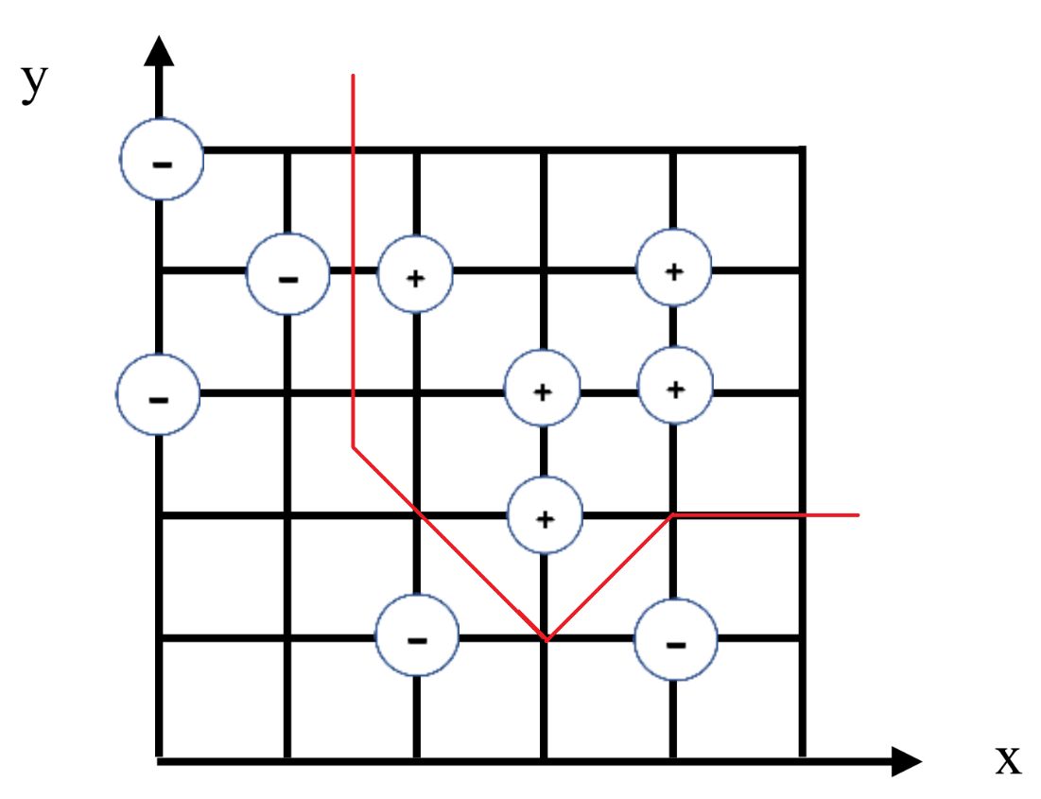

* 1. [Link](https://github.com/hgleos/CS4210-Machine-Learning/blob/main/Assignment%202/knn.py)

|  |  |  |  |  |  |
| --- | --- | --- | --- | --- | --- |
| **ID** | **Red** | **Green** | **Blue** | **Class** | **Distance to 10** |
| 8 | 176 | 224 | 23 | 3 | 39.674 |
| 5 | 107 | 142 | 35 | 2 | 80.019 |
| 4 | 144 | 238 | 144 | 2 | 100.125 |
| 3 | 250 | 128 | 14 | 1 | 128.222 |
| 6 | 46 | 139 | 87 | 2 | 131.867 |
| 2 | 255 | 99 | 21 | 1 | 149.258 |
| 7 | 64 | 224 | 208 | 3 | 182.825 |
| 1 | 220 | 20 | 60 | 1 | 196.675 |
| 9 | 100 | 149 | 237 | 3 | 202.536 |
| 10 | 154 | 205 | 50 | ????? |  |

The predicted class will be 2 based on 3NN.

$P\left(class=no \right| Outlook=Sunny, Temp=Mild, Humidity=Normal, Wind=Weak)$

$=P\left(Outlook=Sunny | class=no\right)* P\left( Temp=Mild | class=no\right)* P\left( Humidity=Normal | class=no\right)* P\left( Wind=Weak | class=no\right)*P(class=no)$

$=\frac{3}{5}*\frac{2}{5}*\frac{1}{5}*\frac{2}{5}*\frac{5}{14}=0.00686$

$P\left(class=yes \right| Outlook=Sunny, Temp=Mild, Humidity=Normal, Wind=Weak)$

$=P\left(Outlook=Sunny | class=yes\right)* P\left( Temp=Mild | class=yes\right)* P\left( Humidity=Normal | class=yes\right)* P\left( Wind=Weak | class=yes\right)*P(class=yes)$

$=\frac{2}{9}*\frac{4}{9}*\frac{6}{9}*\frac{6}{9}*\frac{9}{14}=0.0282$

Normalized:

* 1. [LINK](https://github.com/hgleos/CS4210-Machine-Learning/blob/main/Assignment%202/naive_bayes.py)